Department of Computer Science and Engineering
Lab Report
Lab Report No | : | 02
Lab Report Name | : | False Position
Course Title | : | Numerical Methods Sessional
Course Code | : | CSE 226
Name | : | Fahim Faisal Pathan
ID | : | 1119033
Level | : | 2 | Term | : | 2 | Section | : | A | Group | : | G2
Date of Submission | : | 04/05/2026 | Semester | : | Spring | Year | : | 2026

Marking Rubric
Problem Understanding & Report Clarity (3) | Implementation (4) | Results, Analysis & Presentation (3) | Total(10)

Key Learning:
1. The code implements the False Position (Regula Falsi) method to find roots of a nonlinear equation.
2. A valid interval requires f(a) × f(b) < 0, ensuring a root exists between a and b.
3. The root is approximated using the formula: $c=\frac{af(b)-bf(a)}{f(b)-f(a)}$.
4. The method iteratively updates the interval based on the sign of f(c).
5. The loop stops when |f(c)| < tolerance (0.0001) for desired accuracy.
6. A formatted table output helps track convergence step-by-step (useful for exams).

Code Input:
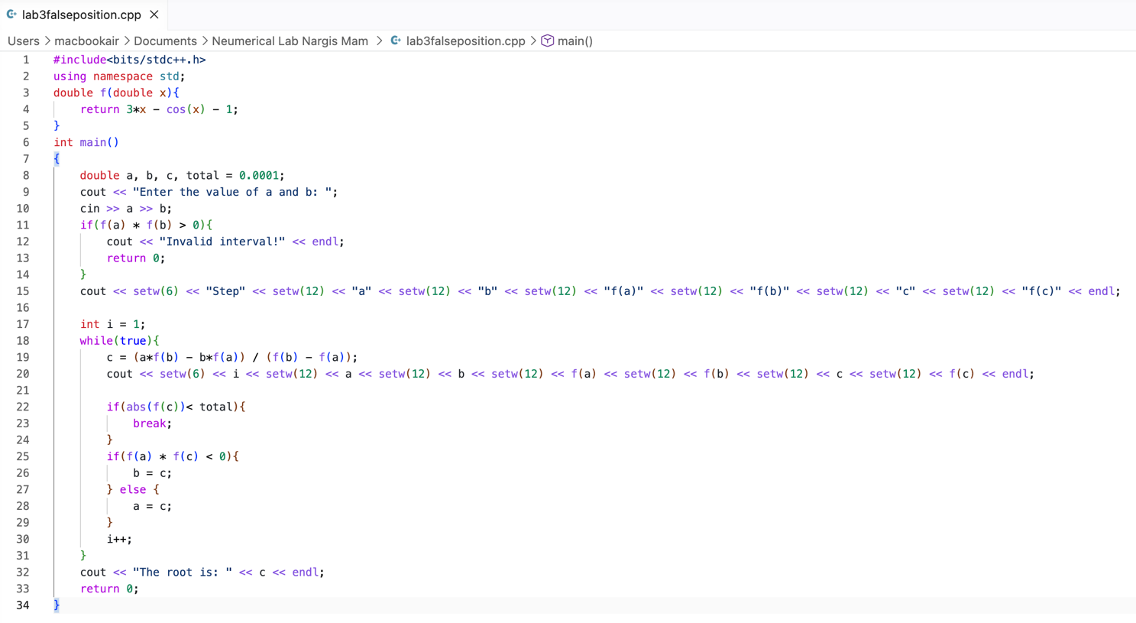

Code Output:
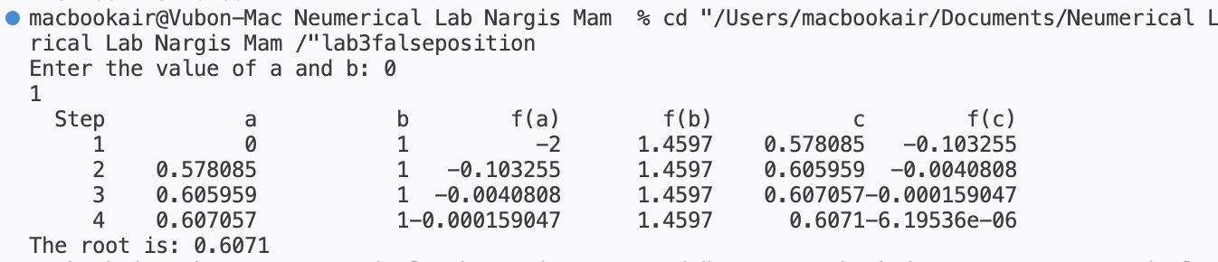

Result Analysis:
- The method converges gradually to the root of the equation $3x-cos⁡(x)-1=0$.
- Each iteration produces a new value of c that moves closer to the actual root.
- The values of f(c) approach zero, showing increasing accuracy.
- The interval $\left[a , b\right]$ shrinks step by step, always keeping the root inside.
- Convergence is faster than Bisection, because it uses a better approximation (secant line).
- Sometimes one endpoint remains fixed for many steps → slower convergence in some cases.
- Final result gives an approximate root with error less than 0.0001, ensuring good precision.

